**Excel Assignment – 9**

**Q1. What are the different margins options and do we adjust the margins of the excel worksheet?**

**Ans:** In Excel, you can adjust the margins of a worksheet before printing it. This ensures that the data is printed correctly and fits within the page boundaries. The different margin options available in Excel are:

1. Top Margin: The amount of blank space left at the top of the printed page.
2. Bottom Margin: The amount of blank space left at the bottom of the printed page.
3. Left Margin: The amount of blank space left at the left-hand side of the printed page.
4. Right Margin: The amount of blank space left at the right-hand side of the printed page.
5. Header Margin: The amount of blank space left at the top of the printed page for the header.
6. Footer Margin: The amount of blank space left at the bottom of the printed page for the footer.

To adjust the margins in Excel, you can follow these steps:

1. Go to the "Page Layout" tab in the ribbon.
2. Click on the "Margins" dropdown in the "Page Setup" group.
3. Select the desired margin option from the list or click on "Custom Margins" to set custom margins.
4. In the "Page Setup" dialog box, you can adjust the margin values by entering the desired values in the input boxes.
5. Click "OK" to apply the changes.

**Q2. Set a background for your table created.**

**Ans:**

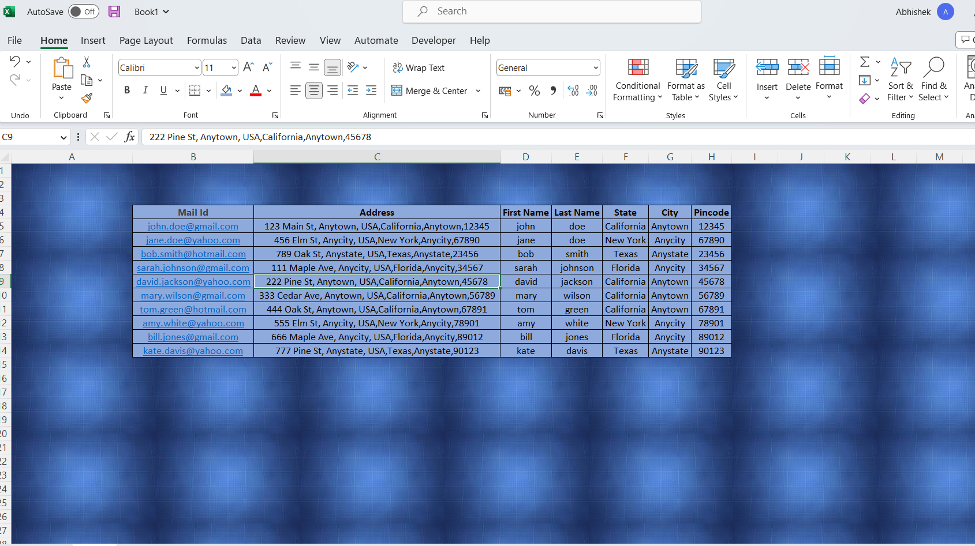

**Q3. What is freeze panes and why do we use freeze panes? Give examples.**

**Ans:** Freeze panes is a feature in Excel that allows users to keep specific rows or columns visible while scrolling through a large dataset. When you freeze panes, the rows and/or columns that are above and to the left of the active cell remain in place while the rest of the worksheet can be scrolled as needed.

There are various scenarios where freeze panes can be useful, such as:

1. When working with a large dataset, freeze panes can always keep the column headers or row labels visible, making it easier to understand the data.
2. When working with a large table, freezing panes can help keep the column or row of the selected cell visible, allowing for better context while scrolling through the data.
3. When working on a comparison table, freeze panes can help to compare values in two different columns or rows without losing track of the information.

Example: Suppose you have a large dataset with customer information that includes names, addresses, phone numbers, and order details. By freezing the top row, you can always keep the column headers visible while scrolling through the data. This will make it easier to understand the data and avoid mistakes in data analysis.

**Q4. What are the different features available within the Freeze Panes command?**

**Ans:** The Freeze Panes command in Excel allows you to freeze specific rows or columns of a worksheet, making them always visible even when you scroll through the rest of the data. The different features available within the Freeze Panes command are:

1. Freeze Top Row: This option freezes the first row of your worksheet and keeps it visible while scrolling through the rest of the data.
2. Freeze First Column: This option freezes the first column of your worksheet and keeps it visible while scrolling through the rest of the data.
3. Freeze Panes: This option allows you to freeze both rows and columns at the same time, making them always visible while scrolling through the rest of the data.
4. Unfreeze Panes: This option unfreezes any frozen rows or columns in your worksheet, allowing you to scroll through all the data again.

**Q5. Explain what the different sheet options present in excel are and what they do?**

**Ans:** In Excel, the different sheet options available are:

1. Rename Sheet: This option allows you to rename the active sheet by double-clicking on the sheet tab and typing a new name.
2. Move or Copy Sheet: This option allows you to move or copy a sheet within a workbook or to a different workbook. To access this option, right-click on the sheet tab and select "Move or Copy Sheet".
3. Delete Sheet: This option allows you to delete the active sheet or a selected sheet from the workbook. To access this option, right-click on the sheet tab and select "Delete".
4. Hide Sheet: This option allows you to hide a sheet from view in the workbook. To access this option, right-click on the sheet tab and select "Hide".
5. Unhide Sheet: This option allows you to unhide a sheet that has been hidden in the workbook. To access this option, right-click on any sheet tab and select "Unhide". Then select the sheet you want to unhide and click OK.
6. Protect Sheet: This option allows you to protect a sheet from being modified by other users. To access this option, click on the "Review" tab and select "Protect Sheet". You can then set a password to protect the sheet.
7. Tab Color: This option allows you to change the color of the sheet tab to make it easier to identify. To access this option, right-click on the sheet tab and select "Tab Color".

These options help in managing the sheets in a workbook and protect them from being modified by unauthorized users.